**Time Series Analysis**

**Assignment – 1**

**Given the data set on revenue and sales quantity of a beverage manufacturer between Jan 2015 to Apr 2020. Suggest appropriate smoothing technique for the series. Compare between the revenue and the average cost. Does the same technique work for both. Justify.**

**Defination:**

In the given question, a time series data is provided and is expected to work on columns of Revenue and Average cost from the dataset. The question can be divided into three parts:

1. To suggest an appropriate smoothing technique among Exponential Smoothing, Double Exponential Smoothing (Holt’s Smoothing) and Triple Exponential Smoothing (Holt-Winter’s Smoothing) for both the columns i.e., Revenue and Average cost.
2. To compare between Revenue and Average cost.
3. To determine whether the same smoothing technique can be applied to both the columns (Revenue and Average cost).

**Analysis:**

Overview:

A time series is a is a set of observations measured at specified (usually equal) time interval. Here, we are interested in smoothing out the series so that the long trend patterns can be revealed and short-term fluctuations can be smoothened out.

In the given dataset, there are four columns Period, Revenue, Sales quantity and Average cost, consisting of 64 observations. The observations are measured at specified and equal time interval and hence the dataset is a time series.

Exponential Smoothing is a weighted moving average technique, where all the past observations are weighted equally. Double Exponential Smoothing (Holt’s Smoothing) is used when trend is present in the series. Triple Exponential Smoothing (Holt-Winter’s Smoothing) is used if the series contain trend as well as seasonality.

Softwares in use:

The softwares that have been used for analysis are MS Excel and R. The smoothing techniques and graphs are done with the help of MS Excel. R is used to check whether the given dataset is a time series, to confirm the presence of trend using the MannKendall test and to confirm the presence of seasonality using the ACF plots.

Results:

 Fig. 1 (a)

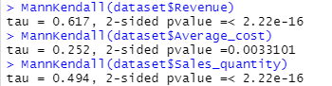 Fig. 1 (b)

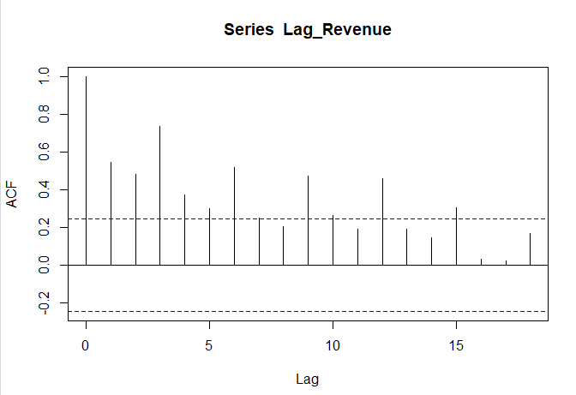 Fig. 2 (a)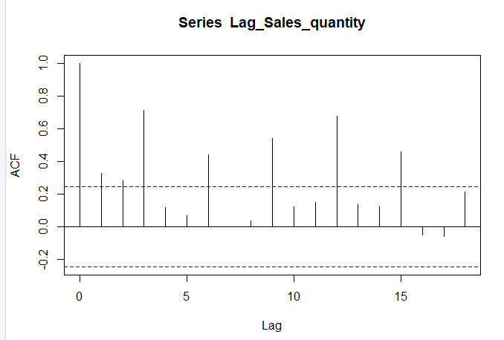 Fig. 2 (b)

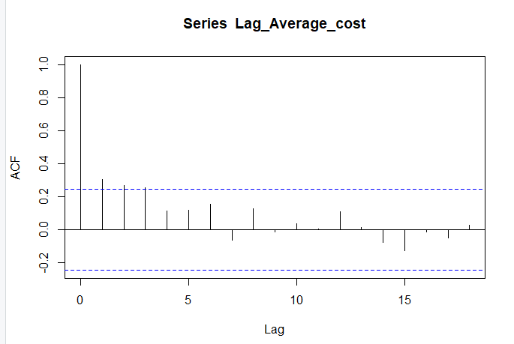 Fig. 2 (c)

Fig. 1

Fig. 3 (a)

Fig. 3 (b)

Fig. 4 (a)

Fig. 4 (b)

Fig. 5

Exploratory Data Analysis:

In the given dataset,

* There is no need of data cleaning as there are no missing observations.
* There is no need of data transformation as the values of the variables lie in the required range.
* There is no need of data integration as there is only one dataset available.
* From data mining, we can see that both trend and seasonality is present in Revenue and Sales quantity and hence we can use Triple Exponential Smoothing (Holt-Winter’s Smoothing).

As only trend is present in Average cost, we can use Double Exponential Smoothing (Holt’s Smoothing).

**Interpretation:**

In Fig.1 (a), using the is.ts() command it is confirmed that the given dataset is a time series.

In Fig.1 (b), with the help of MannKendall test we can interpret that trend is present in the given dataset as the p-values of Revenue, Sales quantity and Average cost are less than 0.05. Also, tau values of Revenue, Sales quantity and Average cost are positive and hence there is a positive trend.

From Fig.2 (a), we can see that seasonality is present in the series for Revenue. Also, from the ACF plot we can see that lag of 3 is present.

From Fig.2 (b), we can see that seasonality is present in the series for Sales quantity. Also, from the ACF plot we can see that lag of 3 is present.

From Fig.2 (c), we can see that seasonality is not present in the series. It can also be understood using the ACF plot since some of the plot lines above the x-axis while some are below the x-axis.

As seasonality is present in the data for Revenue and Sales quantity, we use Triple Exponential Smoothing (Holt-Winter’s Smoothing) for both taking values of α (data Smoothing factor), β(trend smoothing factor) and γ(seasonality smoothing factor) as 0.3, 0.4 and 0.5 respectively. The graphs of Triple Exponential Smoothing (Holt-Winter’s Smoothing) for Revenue and Sales quantity are shown in Fig.3 (a) and Fig.4 (a) respectively.

In Fig.3 (b) and Fig.4 (b), the graphs are plotted for actual values of Revenue and Sales quantity against predicted values of Revenue and Sales quantity. It can be seen that the predicted values are close to the actual values, which indicates that the series is smoothened.

In Average cost as there is trend and no seasonality, Double Exponential Smoothing (Holt’s Smoothing) is used. The values for α (data Smoothing factor), and β (trend smoothing factor) are 0.3 and 0.4 respectively. The graph of the same is shown in Fig.5.

**Conclusion:**

From the above analysis, we can conclude that Triple Exponential Smoothing (Holt-Winter’s Smoothing) is the appropriate smoothing technique for Revenue and Sales quantity, whereas Double Exponential Smoothing (Holt’s Smoothing) is the appropriate smoothing technique for Average cost.

We can compare Revenue and Average cost by taking into consideration the smoothing techniques used which are different since seasonality is present in Revenue, but not present in Average cost.